HTML - Practise

Design the tabes as shown

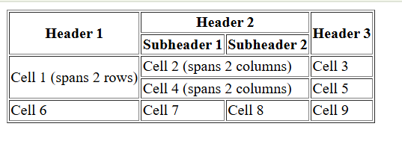

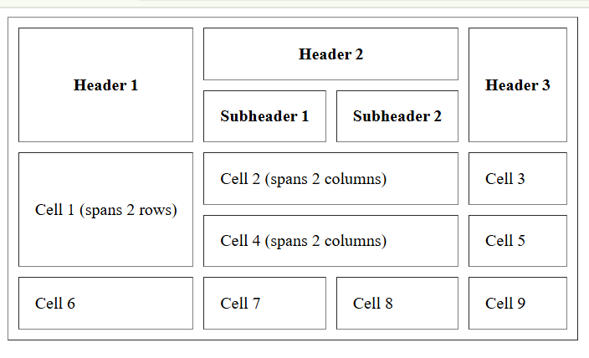

Design and implement an Employee Registration Form using HTML that collects essential employee details, including personal information, employment details, emergency contact, address, and login credentials. The form should be well-structured using fieldsets and legends for organization and include necessary validations as part of form to ensure data accuracy.

|  |  |  |  |
| --- | --- | --- | --- |
| Section | Field Name | Input Type | Validations / Constraints |
| Personal Information | First Name | Text | Required, Alphabetic Only |
| Last Name | Text | Required, Alphabetic Only |
| Email | Email | Required, Must be a valid email format |
| Phone Number | Tel | Required, Numeric Only |
| Gender | Radio Buttons | Required (Male, Female, Other) |
| Date of Birth | Date | Required |
| Marital Status | Radio Buttons | Required (Single, Married) |
| Spouse Name | Text (Optional) | Required if Married |
| Employment Details | Department | Dropdown | Required (HR, IT, Finance, Marketing) |
| Years of Experience | Number | Must be 0 or greater |
| Skills | Checkboxes | Multiple selections allowed (HTML, CSS, JavaScript, SQL) |
| Certifications | Textarea (Non-Expandable) | Optional |
| Profile Picture | File Upload | Only .jpg or .png formats allowed |
| Emergency Contact | Contact Name | Text | Required |
| Contact Phone | Tel | Required, Numeric Only |
| Relationship | Text | Required (e.g., Parent, Spouse) |
| Address Details | Address | Textarea (Non-Expandable) | Required |
| Login Details | Username | Text | Required |
| Password | Password | Required |
| Confirm Password | Password | Required, Must match Password |
| Form Submission | Submit Button | Submit | Registers the user |
| Clear Button | Reset | Clears the form |

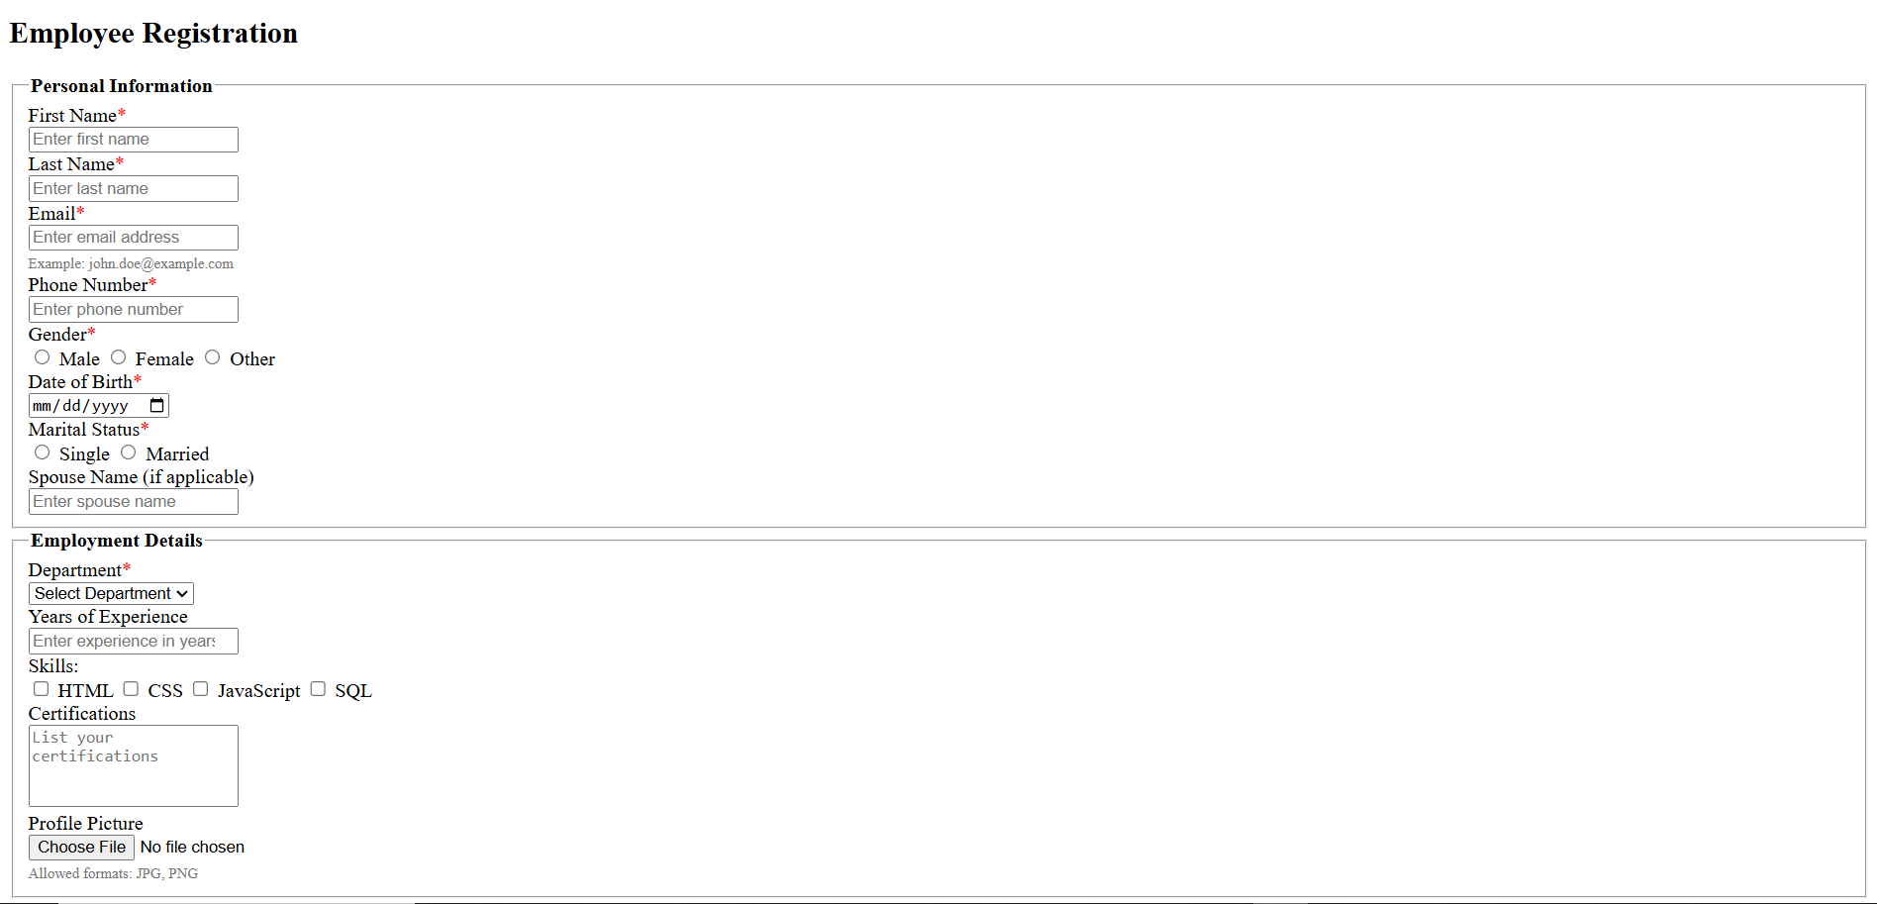

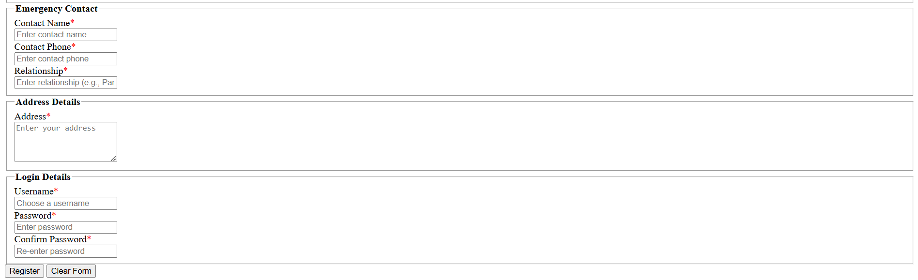

Simple Webpage

Create an HTML5 page with a header, footer, and main section. The header should have a title and a navigation menu. The main section should contain an article with an image and a paragraph. The footer should have copyright information.

Responsive Layout Using HTML5 Elements

Create a webpage with a section, aside, and article layout. Use the <nav> tag for navigation links. Structure the page properly using semantic elements





